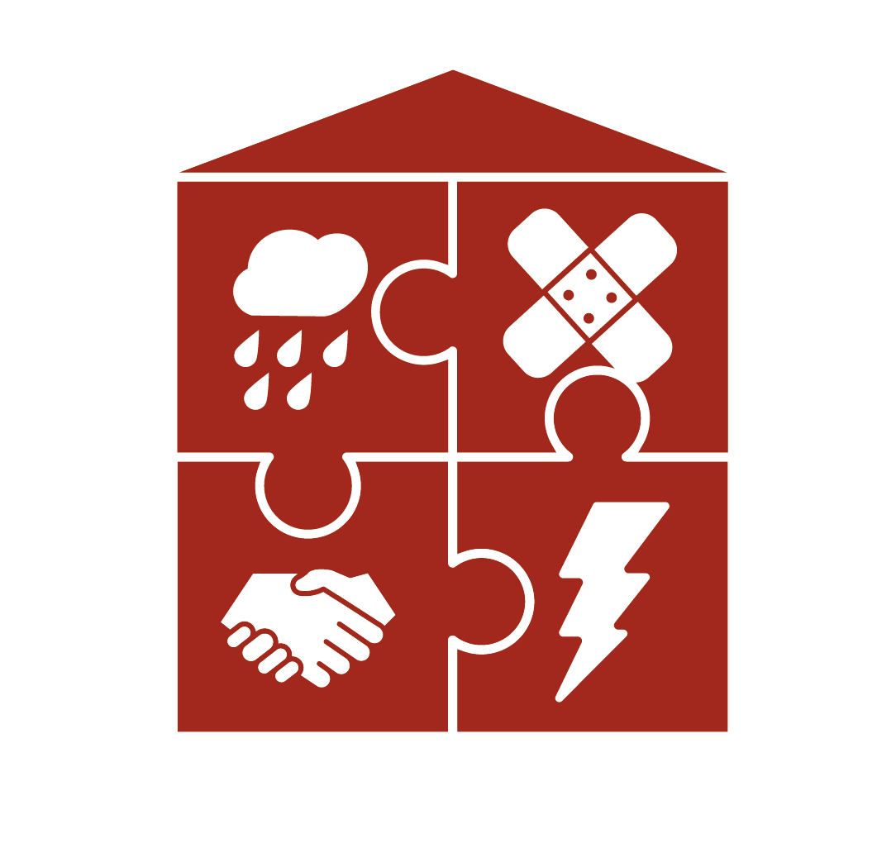
Our kindergarten
is safe!

Dear Parents!

Let us ask you a personal question: How familiar are you with first aid?
At some point in your life you probably already have completed a first aid course.
Do you remember when that was? Could you help in an emergency?

We, the teachers of nursery in your child's kindergarten, have been working intensively on this question. What happens in an emergency when seconds count?
Does everyone know what to do? Do you know who the responsible authorities and the contact persons are? Is our kindergarten prepared to react correctly in emergency situations?

We have decided to make our kindergarten even safer. Every child should know what first aid is and what to do when it is needed. Who should be informed? Where is the first aid kit? All kindergarten children should have the opportunity to train their knowledge by means of playful activities.

Our kindergarten would like to obtain the "Sicherer Kindergarten" seal of approval, which is awarded by the Austrian Youth Red Cross and AUVA.

With this seal we increase the safety standard in our kindergarten and the competence of
all persons who are in the kindergarten - this includes the pedagogues and employees of the kindergarten, as well as every child attending our kindergarten.

If you are interested, you can find more detailed information about the program online at www.sichererkindergarten.at. We will keep you informed about our way to obtain the "Sicherer Kindergarten” certificate!

